**‘Microscale Phase Change on Nano/Micro Textured Surfaces’**

## A Thesis Submitted

In Partial Fulfillment of the Requirements

for the Degree of

## Master of Technology

by

**“Aakash Agarwal”**

**(2017MED1001)**

DEPARTMENT OF MECHANICAL ENGINEERING

INDIAN INSTITUTE OF TECHNOLOGY ROPAR

MAY 2022

Copyright © “2022” by Indian Institute of Technology Ropar

DEDICATED

TO

FAMILY & FRIENDS

# **DECLARATION**

I declare that this work entitled “Microscale Phase Change on Micro/Nano Textured Surface” has not previously been accepted in substance for any degree and is not being simultaneously submitted in candidature for any other degree. This thesis is being presented in partial fulfillment of the requirements for the Degree of MTECH in Mechanical Engineering. This thesis is the result of my independent investigation, except otherwise stated. I have acknowledged all the other sources by stating the references explicitly. I declare that any idea/data/fact/source said in my thesis has not been fabricated/falsified/misrepresented. All the principles of academic honesty and integrity have been followed. I understand that any violation of the above will be cause for disciplinary action by the Institute and can also evoke penal action from the sources which have thus not been appropriately cited or from whom proper permission has not been taken when needed. If accepted, I hereby consent for my thesis to be available online in the Institute’s Open Access repository, inter-library loan, and the title and abstract to be made available to outside organizations.

Signature

Aakash Agarwal

2017MED1001

Date:08/05/2022

# 

# **ACKNOWLEDGMENTS**

I want to take this opportunity to express my deep sense of gratitude and profound feeling of admiration for my thesis supervisor. Many thanks to all those who helped me in this work.

# **CERTIFICATE**

It is certified that the work contained in the thesis titled “Microscale Phase Change on Micro/Nano Textured Surface” by “Aakash Agarwal” has been carried out under my supervision. This work has not been submitted elsewhere for the award of any degree.

**Signature of the Supervisor**

**Chander Shekhar Sharma**

**Mechanical Engineering**

**IIT Ropar**

# **LAY SUMMARY**

Condensation is widely observed in nature and is essential in energy conversion, water harvesting, and thermal management systems. As the need for computational resources increases, so does the need for better thermal management of these systems. Improvements in heat transfer can achieve considerable savings of energy and resources during this phase change process. Condensers in thermal power plants can also be made more effective by enhancing the phase change process by dropwise condensation hence increasing the overall efficiency of the power plant.

# **ABSTRACT**

Dropwise Condensation enhances heat transfer against filmwise condensation, which is advantageous for high-performance thermal management, efficient water harvesting, and improved heat transfer in condensers. This study aims to develop robust superhydrophobic micro/nanostructured surfaces that offer long-term dropwise condensation and test their heat transfer characteristics.

These surfaces are intended to be Cassie stable, which favors the development of the suspended droplets on the micro/nanotextured surfaces contrasted with the partially wetting drops that wet the base of the microstructures. The shedding pace of the drops from the surface needs to be increased to restore the surface for condensation. We also intend to test these surfaces for heat transfer characteristics in our condensation chamber setup. Once the setup is assembled, various tests are performed on it as per the protocol, and the setup will be validated against the Nusselt correlation.

# **LIST OF PUBLICATIONS**

# ***Journal papers***

# ***Conference papers***

# ***Book Chapters***

# ***Patents***

**TABLE OF CONTENTS**

DECLARATION iv

ACKNOWLEDGMENTS v

CERTIFICATE vi

LAY SUMMARY vii

ABSTRACT viii

LIST OF PUBLICATIONS ix

*Journal papers* ix

*Conference papers* ix

*Book Chapters* ix

*Patents* ix

LIST OF FIGURES xii

LIST OF TABLES xiii

NOTATIONS AND ABBREVIATIONS xiv

CHAPTER 1 1

INTRODUCTION 1

*Motivation* 1

*Background* 1

*Filmwise and Dropwise Condensation* 1

*Why Dropwise Condensation?* 1

*Wetting Behaviour and Heat Transfer* 1

*Wenzel and Cassie-Baxter Model* 2

CHAPTER 2 4

LITERATURE REVIEW 4

*Filmwise Condensation* 4

*Dropwise Condensation* 4

*Droplet Nucleation* 4

*Droplet Growth* 5

*Droplet Shedding* 5

*Biphilic Surfaces* 6

*Review of Other Setup* 7

CHAPTER 3 8

EXPERIMENTAL WORK 8

*Setup Overview* 8

*Leakage Test* 9

*Chiller Test* 9

*Vacuum Test* 9

*Assembly* 9

*DAQ* 10

*LabView Program* 10

*Boiler Testing* 11

*Sample Mounting and Testing* 11

*Experimental Protocol* 12

*Initial Steps* 12

*Vacuuming* 12

*Steam Generation* 12

*Experiment* 12

*Post Processing* 13

CHAPTER 4 14

NUMERICAL SIMULATIONS 14

*Governing Equations* 14

*Results for Across the Groove Simulations* 15

*Results for Along the Groove Simulations* 17

CHAPTER 5 19

RESULTS AND DISCUSSIONS 19

*Vacuum Test* 19

*Sensors Connectivity* 21

*Pressure Sensors* 21

*PT100 Sensors* 21

*PT1000 Sensors* 21

*Thermocouples* 22

*Tests and Improvements* 22

*Experimental Results* 24

*Numerical Results* 26

CHAPTER 6 27

CONCLUSION 27

APPENDIX 30

*Matlab Code* 30

*Steady State Check* 30

*Heat Flux calculation* 30

# **LIST OF FIGURES**

Figure i Wetting Behaviour2 2

Figure ii Schematic of the Setup 8

Figure iii LabVIEW program to measure the pressure inside the chamber 10

Figure iv LabVIEW Program to measure the temperature from thermocouples and write the data in a file 11

Figure v LabVIEW Program to measure the temperature from RTD’s and write the data in a file 11

Figure vi Time evolution of the two droplets coalescing across the groove. 16

Figure vii Time evolution of the two droplets coalescing on a biphilic surface along the groove with droplet jumping after coalescing. 18

Figure viii Leakage Test of the Chamber. The minimum pressure achieved was 0.13 mbar and a leakage rate of 359.28 mbar/hr. 19

Figure ix Leakage Test of the Chamber. The minimum pressure achieved was 0.13 mbar and a leakage rate of 352.44 mbar/hr. 20

Figure x Leakage Test of the Chamber. The minimum pressure achieved was 0.05 mbar and a leakage rate of 38.16 mbar/hr. 20

Figure xi Leakage Test of the Chamber. The minimum pressure achieved was 0.04 mbar and a leakage rate of 0.2 mbar/hr at 20 mbar. 21

Figure xii A slot on the gasket acting as a passage for the condensate sliding down the surface. 22

Figure xiii RTD sensors are attached to the clamp to measure the surface temperature. 23

Figure xiv Heat Flux vs. Subcooling for Super hydrophilic Sample 25

Figure xv Heat Flux vs. Subcooling for Superhydrophobic Sample 25

Figure xvi Heat Flux vs. Subcooling for Super hydrophilic sample after improvements. 26

# **LIST OF TABLES**

Table i Simulation for different sets of parameters. 15

Table ii Simulation for different groups of parameters. 17

# **NOTATIONS AND ABBREVIATIONS**

***Symbols***

*A* Area [m2]

*p* Pressure [N/m2]

u Velocity[m/s]

*T* Temperature [K]

*t* Time [s]

g Gravitational Acceleration [m/s2]

r Surface Roughness

f1 area fraction of solid

f2 area fraction of air

S Spreading parameter [J/m2]

ɣsl liquid/solid interfacial energy [J/m2]

ɣsg gas/solid surface energy [J/m2]

ɣlg gas/liquid surface tension [J/m2]

k Thermal Conductivity [W/mK]

Temperature Gradient [K/m]

h Heat Transfer Coefficient [W/m2K]

Steam Temperature [°C]

Surface Temperature [°C]

***Greek Symbols***

*α* Phase fraction

*ρ* Density

θ* Apparent contact angle

θ Equilibrium contact angle

τij Viscous Stresses

τtij Turbulent Stresses

fσi Surface Tension

Heat Flux

***Abbreviations***

CNT Carbon Nanotubes

DAQ Data Acquisition System

RTD Resistance Temperature Detector

DWC Dropwise Condensation

FWC Filmwise Condensation

PW Partially Wetting

S Suspended

# **CHAPTER 1**

# **INTRODUCTION**

## ***Motivation***

Condensation is widely observed in nature and is essential in energy conversion, water harvesting, and thermal management systems. As the need for computational resources increases, so does the need for better thermal management of these systems. Improvements in heat transfer can achieve considerable savings of energy and resources during this phase change process. Condensers in thermal power plants can also be made more effective by enhancing the phase change process by dropwise condensation hence increasing the overall efficiency of the power plant.

## ***Background***

### *Filmwise and Dropwise Condensation*

In filmwise condensation, the condensate forms a liquid film from top to bottom that slides down under the influence of gravity. Heat Transfer is impeded due to the condensate layer between the solid surface and the vapor. The thickness of the liquid film increases as more vapor condenses on the film in the flow direction.

In DWC, instead of a continuous film, the surface is covered by droplets of varying sizes. As the drops grow and merge, their weight leads them to shed, exposing the surface to steam again for condensation.

### *Why Dropwise Condensation?*

The Heat Flux in DWC is more than in FWC. The drops in DWC are discrete and are continually formed and shed, which means the surface is continuously available for condensation. In comparison, the film created in FWC always covers the surface. This film creates additional thermal resistance to the heat transfer, i.e., the Heat Flux is lower filmwise than dropwise condensation. Lower heat flux means less net heat transfer rate for filmwise condensation for a given surface area. Hence, dropwise condensation is preferred.

### *Wetting Behaviour and Heat Transfer*

Contrarily to the molecule in bulk, the molecules at the interface between two mediums are “missing half of their attractive interaction,” those molecules are under tension. This phenomenon is called surface tension. It has consequences that creating more interfaces is energetically costly as you have to compensate for the force pulling the new surface molecules to the bulk. The surface energy quantifies it noted ɣinterface expressed in [J/m2] representing the energy per area needed to increase the interface area.

The concept of surface tension is required to introduce the idea of wettability represented in Figure 1.1. You can see a liquid film lying on a solid in this figure. There are three different interfaces, as shown in the figure. An arrow represents each surface energy. The wetting behavior will depend on the values of those three-surface energies and can be determined with the help of the spreading parameter S1:

If S > 0, it means the surface energy of the solid-gas interface is more significant than the sum of the two others. Therefore, the water will completely spread on the surface to minimize the solid-gas interface area and reach the point of minimum energy. It is the complete wetting state shown on the left in Figure 1.1. When the water condenses on a surface in this configuration, this is called the filmwise condensation mode.

The other case is called partial-wetting, dropwise mode in the case of condensation. If S < 0, The the water will stop spreading and form a droplet characterized at equilibrium by a contact angle θ given by Young’s equation

Hydrophilic surfaces have ‘θ’ lower than 90°, and hydrophobic surfaces have ‘θ’ higher than 90°.

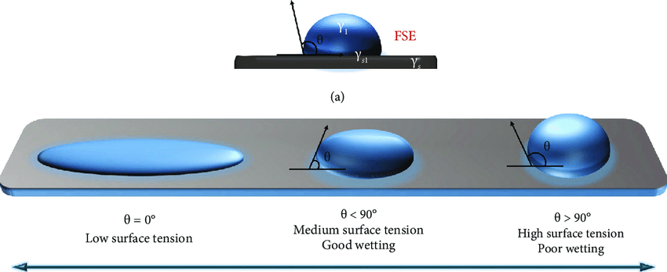

Figure i Wetting Behaviour2

The wetting behavior has a considerable influence on the heat transfer when it comes to condensation. When the steam condensates on the surface that is sub-cooled by a coolant fluid in a surface condenser, the heat flows from the steam to the coolant fluid. The presence of liquid water on the surface adds a thermal resistance to the heat transfer, i.e., the heat transfer is more efficient in dropwise condensation.

### *Wenzel and Cassie-Baxter Model*

The contact angle can be described by two models on an actual surface, i.e., a solid surface with surface roughness and chemical heterogeneity. The Wenzel model considers the rough surface with chemical homogeneity, and the Cassie-Baxter model considers the flat surface with chemical heterogeneity

The surface roughness(r) in the Wenzel model is defined as the textured surface area to the projected surface area. Wenzel model is described as1:

***\****

TheCassie Baxter equation is written as:

From the Wenzel model, we can deduce that the surface’s wettability increases as the surface roughness increases. In the Cassie-Baxter model, the area fraction under the droplet is essential as the contact angle increases with the increase in the area fraction of air.

# **CHAPTER 2**

# **LITERATURE REVIEW**

Condensation Heat Transfer enhancement has been extensively researched due to the economic benefits of increasing the heat transfer coefficient. Researchers have focused on enhancing the heat transfer coefficient in filmwise and dropwise condensation, but most recent research has focused on sustainable and enhanced dropwise condensation. Studies have been done on the lifecycle of dropwise condensation, such as droplet nucleation, growth, and shedding, to improve heat transfer on superhydrophobic and micro/nanotextured surfaces.

Although studies have been done on dropwise condensation heat transfer on superhydrophobic and hydrophobic micro-textured surfaces and phenomena such as self-generated coalescence cascade, Laplace pressure-driven droplet shedding, and coalescence induced jumping of droplets have been observed. Still, we want to introduce a mechanism to remove the large droplets from the surface at capillary length scales, independent of gravity which can significantly enhance dropwise condensation.

## ***Filmwise Condensation***

Zheng et al.(2016)3 used porous coating to adjust surface physical properties and increase transport phenomena. They created a single absorbent layer with the help of sintering. They investigated the heat transfer enhancement and the effect of powder size on the extent of condensation heat transfer improvement.

In another study, Peng et al. (2014)4 analyzed the heat transfer characteristics by combining the FWC with DWC and studied the heat transfer characteristic of the dropwise region and its dependence on maximum droplet radius and filmwise area and its reliance on liquid film thickness. Surfaces with considerable contact angle hysteresis or a smaller contact angle can enhance their condensation heat transfer under low surface subcooling by this hybrid surface.

## ***Dropwise Condensation***

Dropwise condensation contains the lifecycle of droplet nucleation, growth, coalescence, and departure. The behavior characteristic of droplets is the basis for understanding the law, building the physical model, and predicting DWC heat transfer performance. Hence, researchers have focused on each aspect of the lifecycle to enhance the DWC heat transfer.

### *Droplet Nucleation*

Pang et al. (2020)5 studied heat transfer performance factors such as contact angle, departure radius, minimum radius, and the number of nucleation sites by numerical simulation. They concluded that the number of nucleation sites affects the heat transfer performance of DWC very significantly. As the number of nucleation sites increases, the number of tiny droplets grows, the area occupied by droplets increases, and the total heat transfer performance is greatly enhanced. They also concluded that enhancement by the superhydrophobic surface is mainly because of the decreasing departure radius, with the proviso that the presence of non-condensable gas leads to droplets at a suspended state.

In another study, Varanasi and Deng (2010)6 showed that preferential nucleation in the hydrophilic regions with hydrophobic and hydrophilic areas could be achieved by the spatial control of the heterogeneous nucleation of water. Hydrophilic tops on hydrophobic textured surfaces promote Cassie-type droplets with droplet shedding properties compared to the superhydrophobic surfaces that exhibit random nucleation behavior. So, these hybrid surfaces can enhance condensation heat transfer.

### *Droplet Growth*

Miljkovic et al. (2012)7 studied condensate growth rates of S and PW droplets on Cassie stable surfaces. Coalescence-induced droplet ejection was observed in both the droplet morphologies, but due to increased contact with the surface, PW droplets showed six times higher growth rates than S droplets. They highlighted the importance of designing Cassie stable nanostructured surfaces to enhance the heat and mass transfer during DWC.

In another study, Niu & Tang (2018)8 used molecular dynamics simulation to study how heat flux, surface wettability, and initial droplet size effects droplet nucleation and growth on the rough surface. They showed that droplet nucleation and growth inside the rough structure could result from high heat flux and leads to the Wenzel state. After coalescence on the surface with high hydrophobicity, the newly formed droplet exhibits a transition from the Wenzel state to the Cassie state. The large droplet on the top restricts the internal nucleation and thus avoids the Wenzel droplet. They also concluded that the flooding mode could be avoided for homogeneous chemical micro-nano structured surfaces if the critical nucleation radius is more than the characteristic size of the spacing.

### *Droplet Shedding*

Sharma et al. (2018)9 achieved enhancement in condensation heat transfer on a textured metallic surface by a combination of vapor shear and coalescence-induced droplet depinning. The droplet ejection was achieved through droplet coalescence of different sizes and was observed through high-resolution imaging. Sustained DWC was observed under harsh vapor shear. The surface showed an enhancement in heat transfer compared to a plain hydrophobic nanostructured surface and a nanostructured hydrophilic surface.

In another study, Sharma et al. (2019)10 showed a microfluidic system that clears the microscale condensed droplets without the requirement for the customary drop evacuation pathways, for example, the utilization of super hydrophobicity for drop rolling and jumping and the use of wettability inclinations for directional droplet transport among others. Condensed droplets were removed by self-generated cascade coalescence of droplets along hydrophobic microgrooves. Droplets, as small as ∼ten μm, were able to sustain the cascading coalescence sequence. It would be favorable in scaled-down phase change applications, for example, small thermal diodes and heat pipes, in case we can observe this at smaller length scales.

In another study, Zhang et al. (2017)11 studied how water condensation and frost formation are affected by the stability of super hydrophobicity. Antifrost properties as a function of intrinsic contact angle were studied for rough surfaces with various surface chemistries. Better anti-icing performance was observed at a higher intrinsic contact angle as the superhydrophobic surface transits into a stable Cassie-Baxter state. They concluded that water could move away from the surface before freezing if a steady Cassie-Baxter state could be maintained.

In another study, Tang et al. (2021)12 designed a superhydrophobic surface with microstructures overlaid with nanostructures to enhance and achieve sustained dropwise condensation. They showed that the micro-nano structures push the condensate from the micro-gaps with the help of upward Laplace pressure and navigated it for coalescence to renew the surface. The surface maintained super hydrophobicity for sustained dropwise condensation by the frequently jumping submillimeter condensate by excess surface energy released during coalescence. The micro-nano structured surface showed a very high heat transfer coefficient at low surface subcooling due to the larger effective condensing area and condensate mobility.

## ***Biphilic Surfaces***

Higher droplet nucleation, faster droplet shedding, and low interfacial thermal resistance favor higher thermal performance during condensation. While the nucleation energy barrier is much lesser on hydrophilic surfaces than on hydrophobic surfaces, which causes a significant enhancement in droplet nucleation density, the hydrophobic coating has a low thermal conductivity, which impedes the heat transfer process. The hydrophobic coating also has a short life span, and durability is of concern as it wears off with time. Recently surfaces with wettability gradients have received considerable attention. They try to use the hydrophilic surface for higher droplet nucleation density and the hydrophobic surface for faster droplet shedding combining them to achieve higher heat transfer characteristics during condensation.

Hou et al. (2014)13 implemented high wetting contrast surfaces inspired by the natural beetle shell with hydrophobic base and hydrophilic tops utilizing energetically favored hydrophilic tops for superior nucleation and growth while hydrophobic base delaying flooding and promoting dropwise condensation. Alizadeh-Birjandi et al. (2019)14compared the heat transfer performance of hydrophobic, hydrophilic, and biphilic surfaces. They found that biphilic surfaces showed higher heat transfer performance than the two via high droplet nucleation and consistent droplet removal.

Anderson et al. (2012)15 introduced a biphilic surface with a hydrophilic base and hydrophobic tops resulting in Hemi-wicking droplets. It relied on Laplace pressure instability to gather drops independent of coalescence-induced droplet growth. In another study, the authors6 investigated hydrophobic–hydrophilic patterning in combination with structured roughness to control heterogeneous nucleation while facilitating efficient droplet shedding spatially.

He et al. (2013)16 developed a unique hierarchically structured superhydrophobic surface composed of pores with hydrophilic polymer coatings at the base of the pores. Their approach allowed for the efficient condensation of water in the hydrophilic region and surface tension–driven droplet jumping. They found a significant increase in condensate removal using biphilic surface chemistry versus uniformly hydrophobic surface chemistry.

Winter and Mccarthy (2020)17 developed a biphilic surface that demonstrated the emergence and shedding of droplets without any external forcing. Droplets nucleate and grow inside the hydrophilic surface structure without a thermal barrier or lower nucleation density as a hydrophobic coating. The growing water slug becomes unstable upon reaching a critical length, making a favorable dewetting transition out of the structure, promoting droplet shedding, and thus leaving channels for new condensate growth. The surface resists flooding inside the structure due to the critical slug length.

## ***Review of Other Setup***

Similar setups for studying condensation have been used in different studies. A copper block is used to measure the heat flux. The copper block is kept in an insulated chamber where saturated steam condensed on the surface under study. Temperature and pressure were monitored in the chamber, and the phase change process on the surface was examined using a high-resolution camera.

Paxson (2011)18 designed an apparatus that carefully selected heat transfer paths to ensure maximum heat flux through the sample and copper block. A series of 4 thermocouples installed into the copper block along the centerline measured heat flux through the copper block. Overall thermal resistance was used to extrapolate the surface temperature. During steady-state high-resolution videos were recorded.

In this study, the effect of the non-condensable gases was not confirmed. To study the impact of vapor velocity, an auxiliary condenser with an electronically controlled actuator needs to regulate the mass flow.

In another study, Emmerich (2016)19 designed the condensation chamber to reduce the distance between the sample and the outside walls and the leakage to limit the quantity of non-condensable gas inside the chamber.

In this study, the authors found issues while measuring the temperature at the sample’s surface. The sensor at the back of the sample did not respond when under pressure between the sample and the copper cooler. A solution for measuring the temperature at the sample’s surface is needed to calculate the heat transfer coefficient. Alternatively, the estimation of the thermal resistance between the sample’s surface and the first sensor in the cooler can be measured. Then knowing the heat flux and the temperature at the first cooler sensor, the sample’s surface temperature can be estimated.

# **CHAPTER 3**

# **EXPERIMENTAL WORK**

An apparatus has been made to simulate these conditions to study dropwise condensation in situations similar to typical thermal power plants and desalination plants. Heat flux would be measured on the sample surfaces during the phase change process to quantify the thermal characteristics of the surface. The surfaces would be clamped in the condensation chamber to measure the heat flux, and high-speed cameras would be used to observe the phenomena.

The components of the setup were fabricated as part of the previous project. The setup was assembled in this project, and various validation tests will be performed, followed by experiments on various surfaces.

## ***Setup Overview***

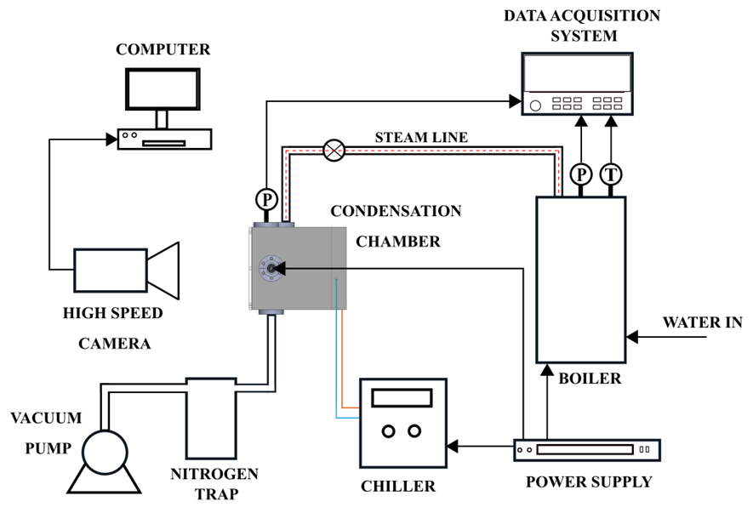

Figure ii Schematic of the Setup

The environment inside our chamber will be saturated steam at low pressure. Most surface coatings degrade at higher temperatures and pressure, so it isn’t easy to measure heat transfer characteristics. We want to measure the sample surface’s heat transfer characteristics and observe the growth dynamics of droplets with high-speed cameras.

We have used a copper block fitted with thermocouples to measure the temperature. The sample surface will be attached to the copper block using a clamp while the other end of the block is exposed to the circulating coolant to cool the surface and sustain condensation at the surface. The heat transfer path is axially one-dimensional. The thermocouples placed at different axial positions measure the temperature of the block, which can be used to measure the heat flux through the block.

The setup comprises different elements: a boiler to generate the steam, valves to orientate the flow, a pressure reduction valve to reduce the pressure, a chamber where the condensation will happen, and a chiller connection to cool the copper block, and a vacuum pump.

The working principle of the condensation chamber and the different parts involved in the setup have been discussed thoroughly in this report20. The remaining work to make the setup ready for experiments is discussed below.

## ***Leakage Test***

Various leakage tests were performed to establish a leakage-proof condensation chamber as non-condensable gases act as a barrier between vapor and the surface, reducing the condensation rate and heat transfer.

### *Chiller Test*

We checked for any leakage in the back cover of the chamber where coolant cools the copper block, and unfortunately, there was leakage of coolant when the chiller was switched on to circulate the coolant.

We used a gasket to seal the back part of the chamber so that there was no coolant leakage during experimentation.

### *Vacuum Test*

We don’t want non-condensable gases in our chamber as they hinder heat transfer during phase change. We need to make sure there is no leakage during the experiment. So, we will test it by creating a vacuum inside the chamber and then observing the pressure inside the chamber to calculate the leakage rate and the time for which the pressure is in our desirable range. Based on this, we can run our experiments for the estimated time. We want to attain a pressure below 0.01 mbar while vacuuming and a leakage rate of 0.5 mbar/h so that the experiment can be performed for a longer duration.

## ***Assembly***

Various components of the setup such as RTD’s, thermocouples, steam inlet, Pressure sensors, Plexi Glass, and Vacuum Pump have been connected. Vacuum Feedthroughs are used for RTD’s which will measure the temperature of the vapor and the sample surface inside the chamber. The Plexi Glass at the front is fixed so that the condensation process can be observed from outside.

## ***DAQ***

DAQ will collect all the sensors data we are using in our setup, such as temperature and pressure sensors. All the sensor connections are to be made to DAQ for data acquisition, and the steady-state values will then be used from the experiment to calculate the heat flux.

Pressure Sensors are connected to the NI-DAQ for acquiring the data while RTD’s and thermocouples have been connected to the Keithley-DAQ for acquiring all the temperature readings.

## ***LabView Program***

LabView will be used to process all the acquired data from the NI-DAQ once it is available so we have developed a LabView program that will be integrated with all the sensors of our setup. The program will calculate the steady-state values of pressure and temperature and calculate the heat flux across the copper block using the temperature data.

The LabView program for taking the data from different sensors such as Pressure, RTD’s, and Thermocouple via DAQ has been made with the check for steady-state values.

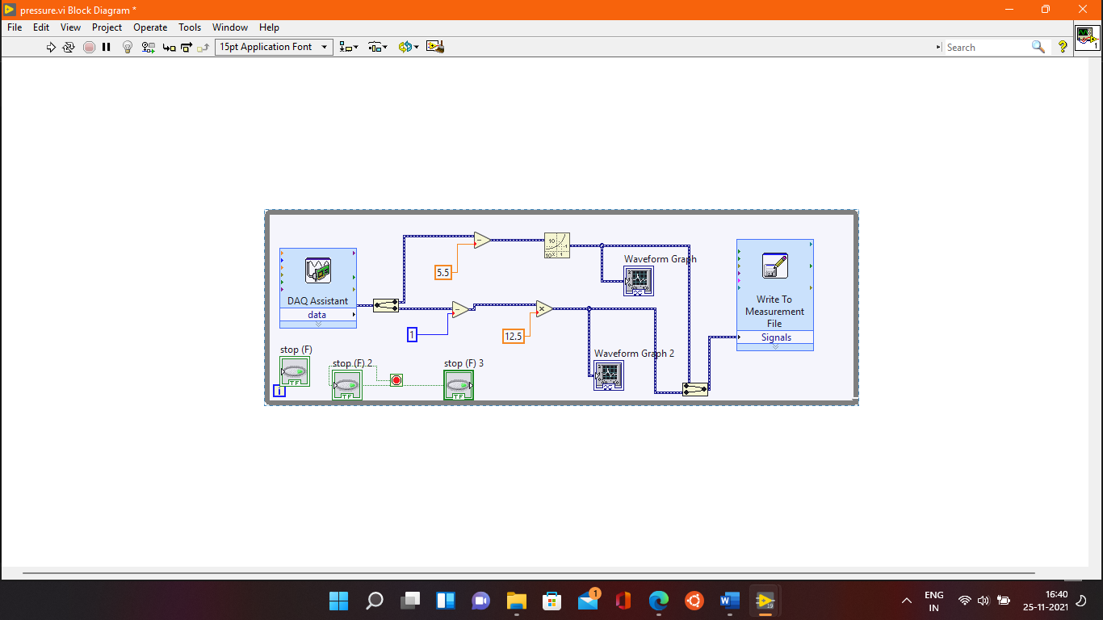

Figure iii LabVIEW program to measure the pressure inside the chamber

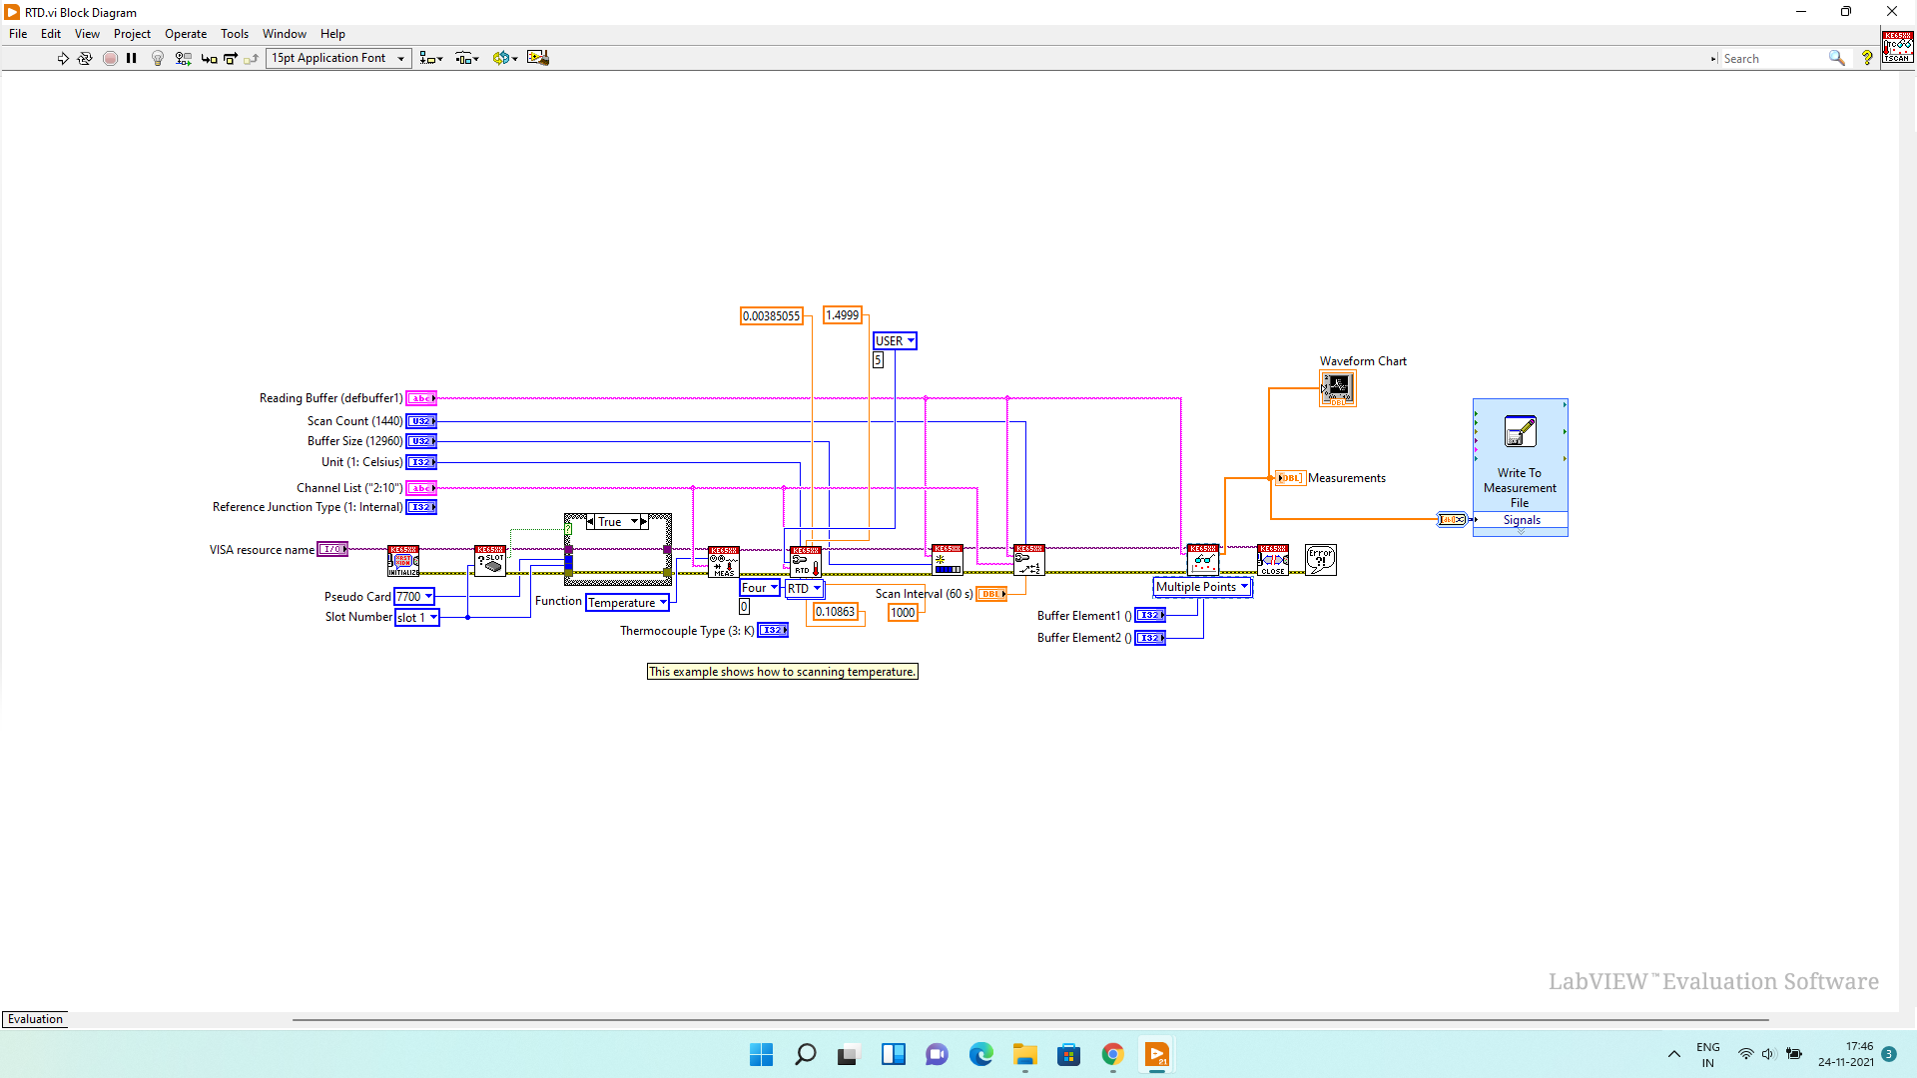

Figure iv LabVIEW Program to measure the temperature from thermocouples and write the data in a file

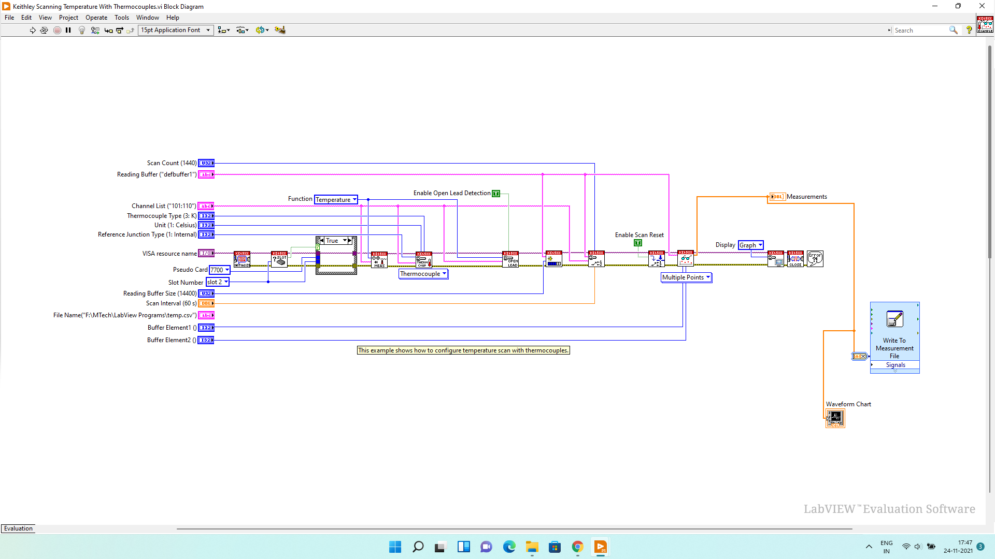

Figure v LabVIEW Program to measure the temperature from RTD’s and write the data in a file

## ***Boiler Testing***

The boiler supplies steam to the condensation chamber at low temperature and pressure, so we checked if the boiler was able to attain the desired pressure and temperature.

## ***Sample Mounting and Testing***

Finally, the sample needs to be mounted on the copper block with the help of clamps, and then the tests were done on the super hydrophilic surface to measure the heat transfer coefficient and validate the Nusselt correlation.

## ***Experimental Protocol***

### *Initial Steps*

* Wipe the water inside the chamber with tissue paper.
* Check if the surface RTD’s are properly connected to the clamp.
* Apply thermal interface material on the copper surface and mount the sample to be tested.
* Apply vacuum grease on the gasket and put the plexiglass at the front.
* Make sure that all the valves and the chamber is closed.
* Check the colour of the vacuum pump oil, it should be transparent otherwise change it.
* Make sure all the electrical connections are alright.
* Set the voltage to 20 on the electrical supply for the pressure sensors and make sure that it is earthed.
* Check if all the coils in the chiller are submerged otherwise top up.
* Make sure there is enough water in the boiler otherwise fill the required amount.
* Empty the water inside the nitrogen trap and connect it to the vacuum line.

### *Vacuuming*

First, pour liquid nitrogen inside the nitrogen trap slowly, let the gases escape, and reach equilibrium. Load the LabVIEW program for pressure reading. After that, switch on the vacuum pump and open the valve to the chamber. The pressure will reduce inside the chamber and stabilize after some time below 0.01 mbar. While the pump is operating, make sure the nitrogen trap is not empty; otherwise, refill it. This ensures that the water vapor does not go inside the vacuum pump and forms an emulsion with the oil.

### *Steam Generation*

After vacuuming, switch on the boiler, and use only one heater as using both may cause a power surge leading to tripping of MCB. Max out the heater and wait till the pressure builds around 1.5 bar inside the boiler. While the pressure is building, drain the air inside the boiler so that steam generation can take place effectively. After reaching the required pressure, drain the steam for 10 minutes to remove any non-condensable gases inside the boiler.

### *Experiment*

Load the Keithley program to acquire the temperature data and check if all the sensors give readings or not, setting the sampling rate to 1Hz. After that, set the chiller to an initial coolant temperature of 20 ℃ to avoid excessive subcooling as fresh steam reaches the condensing surface. Steam is then introduced into the chamber by turning the steam control valve. The low-pressure steam passes through an insulated hose to prevent condensation before entering the chamber. Pressure and temperature sensors are connected to the chamber to monitor steam and surface conditions. Introduce steam by rotating the metering valve for three total rounds, open the vacuum pump valve and fine-tune it to stabilize the pressure inside the chamber between 30-36 mbar. Reduce the heater power such that the pressure inside the boiler is stable at 1.5 bar. As soon as pressure is stabilized, the coolant temperature is reduced to different values to increase the surface’s subcooling. During the experiment, make sure to fill the nitrogen trap at regular intervals.

For a particular chiller temperature, wait for the temperatures to reach steady-state and then take a reading for 10 minutes. Repeat the procedure for different chiller temperatures to get readings at different subcooling. While running the experiment, if the ambient pressure inside the chamber goes out of the range while running the experiment, tune the pressure by controlling the vacuum valve or steam metering valve.

### *Post Processing*

All the temperature readings from different sensors are taken in an excel sheet. The data is processed In MATLAB to filter the steady-state data. The steady-state is calculated by taking 120 rolling data points and checking if the standard deviation of all the sensor’s data is less than the threshold. If the data points are in a steady-state, we take the average of the set of data of all sensors and store it in another file.

Of the four PT100 RTD installed in the block, we notice that there was a deviation in the reading of the 2nd RTD from the front and was not showing linear tread in reading. So, we decided to –use only 1st, 3rd and 4th RTD to calculate the heat flux along the copper block. Linear least-square fit was performed on the reading of the RTD’s to calculate along the copper block, where is the temperature gradient. The heat flux is calculated as per the formula given below:

The surface temperature () is calculated by taking the average of two PT1000 sensors kept on the clamp. The ambient temperature () is calculated by taking the average of two PT1000 sensors kept inside the chamber.

The heat transfer coefficient is calculated by the formula given below:

All these calculations (heat flux and heat transfer coefficient) are carried out in MATLAB nd saved, in another file along with the level of subcooling. The subcooling here is defined as the difference between ambient temperature () and surface temperature ().

After getting all the parameters, different plots can be generated to look into the performance of the sample.

# **CHAPTER 4**

# **NUMERICAL SIMULATIONS**

Numerical simulations were performed to study droplet coalescence on micro-textured surfaces to see if coalescence-induced jumping occurred on these hydrophobic micro-textured surfaces.

OpenFOAM is an open-source software primarily used to solve continuum mechanics problems, most prominently including computational fluid dynamics.

InterFoam solver, a volume of fluid (VOF) based solver for two incompressible, isothermal immiscible fluids, was utilized for the simulation.

2D and 3D simulations were done on microtextured surfaces by changing the texture parameters such as height, width, and spacing of the groove to observe coalescence-induced droplet jumping.

## ***Governing Equations***

The solver solves Navier Stokes equations for two isothermal, incompressible, and immiscible fluids. Material properties are constant in the region filled by one of the two fluids except at the interphase21.

1

2

The density ρ is defined as follows:

3

= 0 4

Equation 1 is the continuity equation, whereas equation 2 is the momentum equation and equation 4 is the interphase equation.

The existence of symmetry planes in the domain helped to divide the domain into four parts, and due to this, computational time was reduced significantly. The faces which can be seen in the figures below are symmetry planes.

Two types of simulations were done for the same parameters: droplets coalescence across the grooves and the other along the grooves.

## ***Results for Across the Groove Simulations***

|  |  |  |  |  |  |
| --- | --- | --- | --- | --- | --- |
| Height  (µm) | Width  (µm) | Spacing  (µm) | Contact  Angle (°) | Droplet  Radius(µm) | Jump |
| 200 | 100 | 250 | 120 | 90 | No |
| 6 | 3 | 7.5 | 110 | 90 | No |
| 9 | 3 | 7.5 | 110 | 90 | No |
| 6 | 3 | 7.5 | 120 | 90 | No |
| 9 | 3 | 7.5 | 120 | 90 | No |
| 11 | 3 | 5.6 | 110 | 90 | No |

Table i Simulation for different sets of parameters.

* Droplet Radius – 90 µ
* Contact Angle – 110 °
* Groove Width – 3 µ
* Groove Height – 11 µ
* Spacing – 5.6 µ

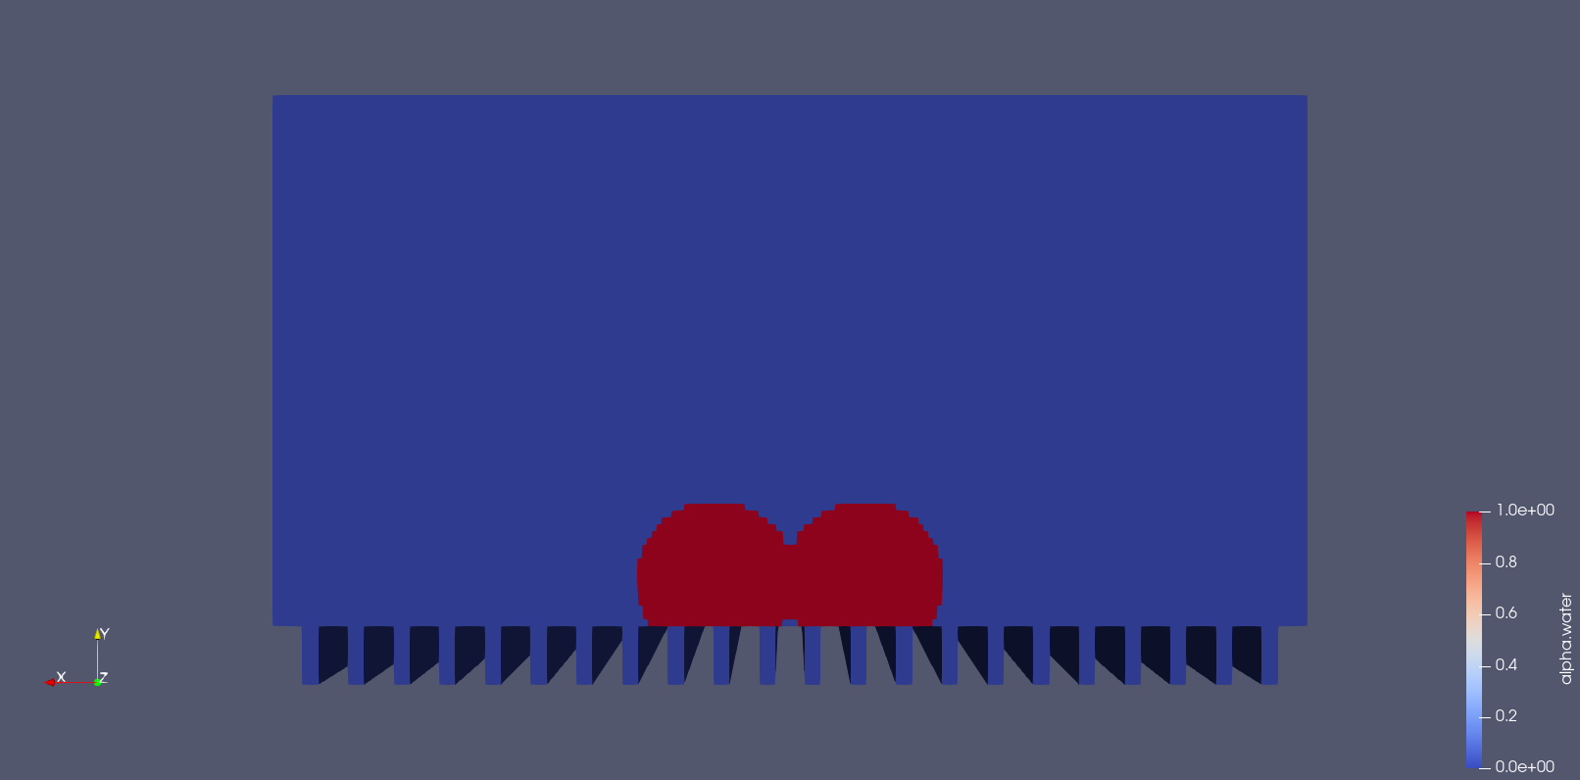 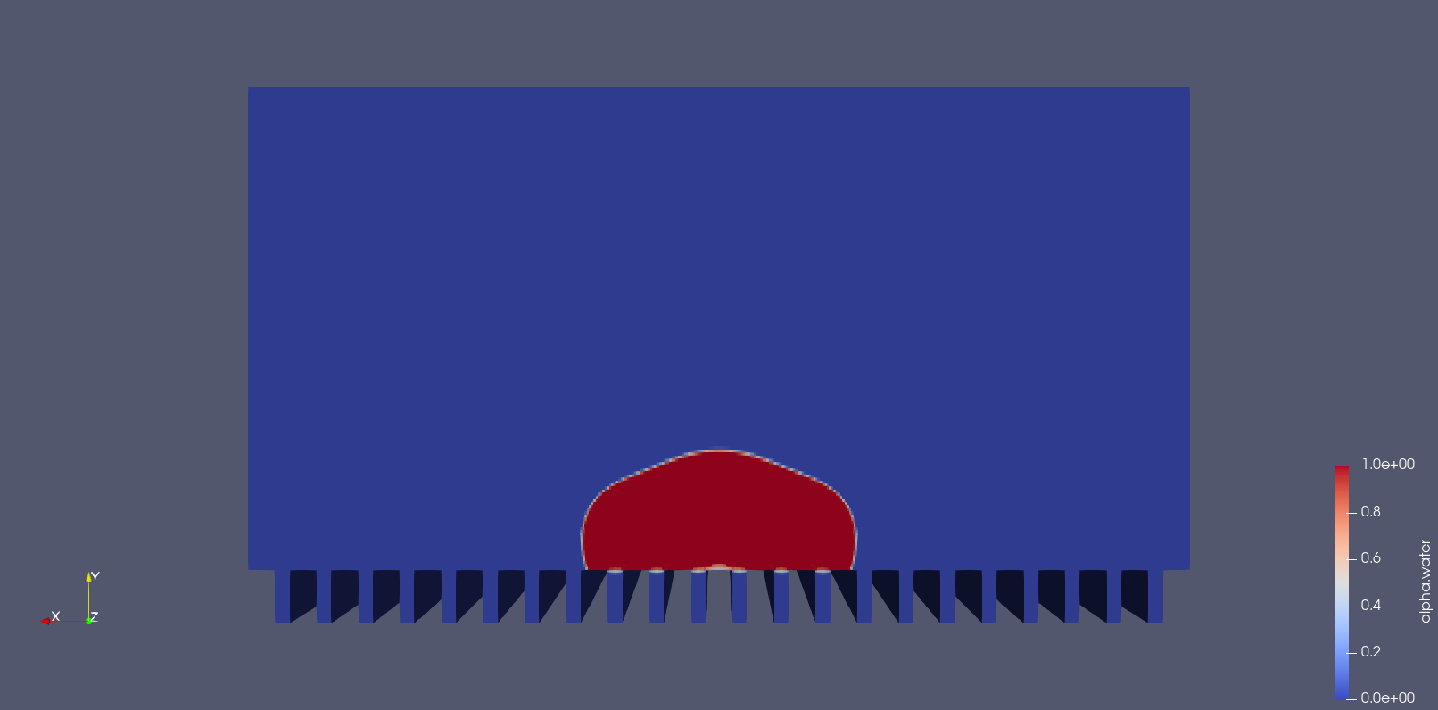

t = 0s t = 0.0001s

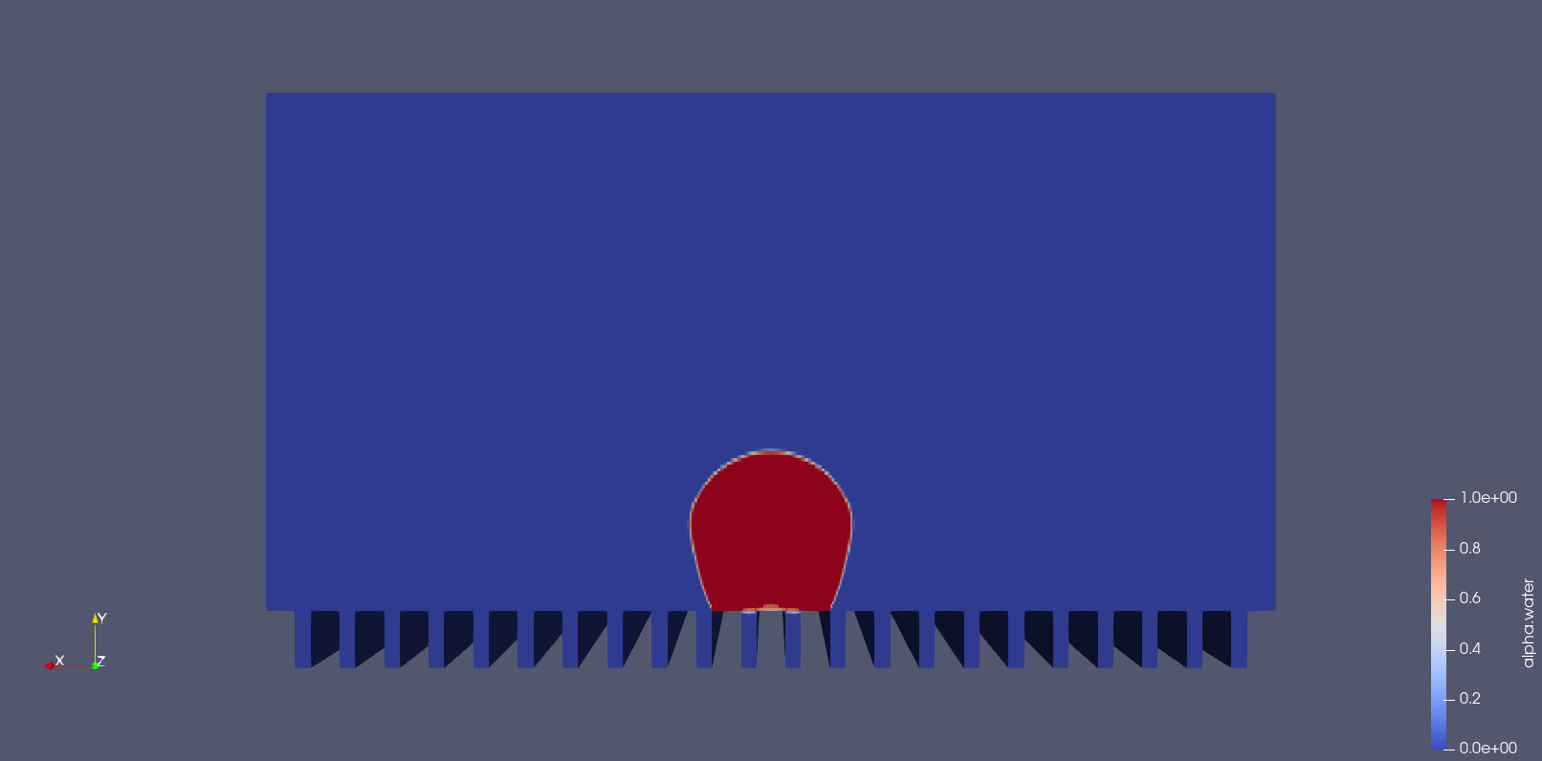 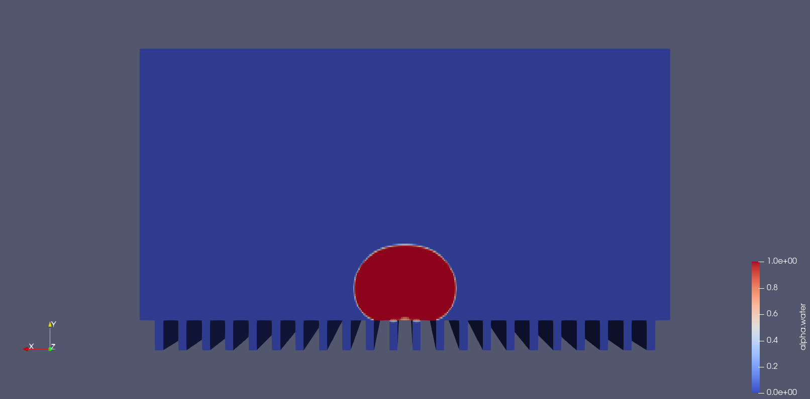

t = 0.0002s t = 0.0005s

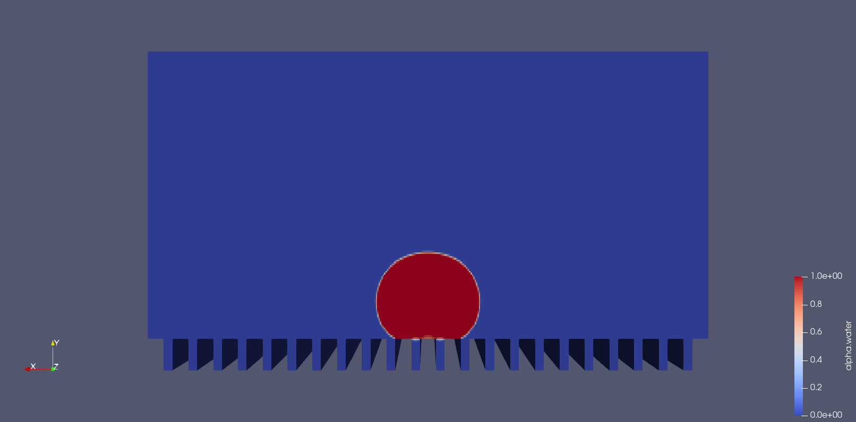 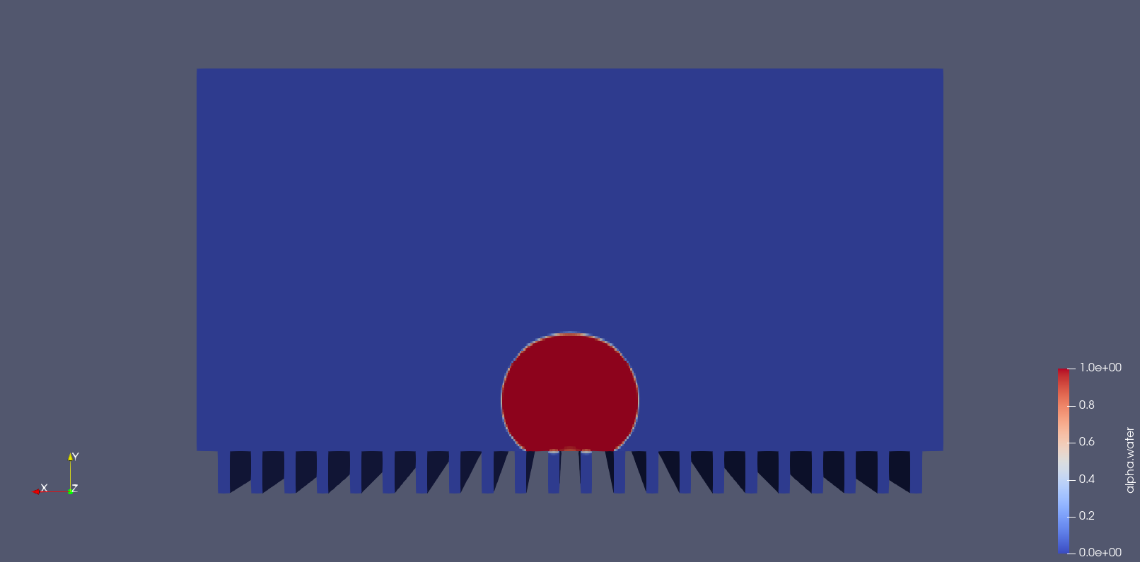

t = 0.0010s t = 0.0015s

Figure vi Time evolution of the two droplets coalescing across the groove.

## ***Results for Along the Groove Simulations***

|  |  |  |  |  |  |
| --- | --- | --- | --- | --- | --- |
| Height  (µm) | Width  (µm) | Spacing  (µm) | Contact  Angle(°) | Droplet  Radius(µm) | Jump |
| 6 | 3 | 7.5 | 120 | 90 | No |
| 200 | 100 | 250 | 120 | 90 | No |
| 9 | 3 | 7.5 | 120 | 90 | No |
| 9 | 3 | 7.5 | 120 | 50 | No |
| 9 | 3 | 7.5 | 120 | 35 | No |
| 11 | 3 | 5.6 | 110 | 90 | No |
| 11 | 3 | 5.6 | 110,160 | 15 | Yes |
| 11 | 3 | 5.6 | 110,160 | 35 | Yes |
| 11 | 3 | 5.6 | 110,160 | 50 | Yes |

Table ii Simulation for different sets of parameters.

* Droplet Radius – 50 µ
* Contact Angle – 110 ° for the grooves and 160° for the ridges
* Groove Width – 3 µ
* Groove Height – 11 µ
* Spacing – 5.6 µ

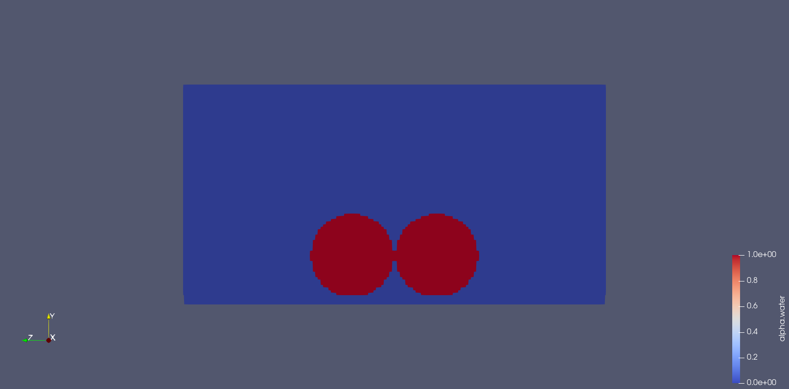 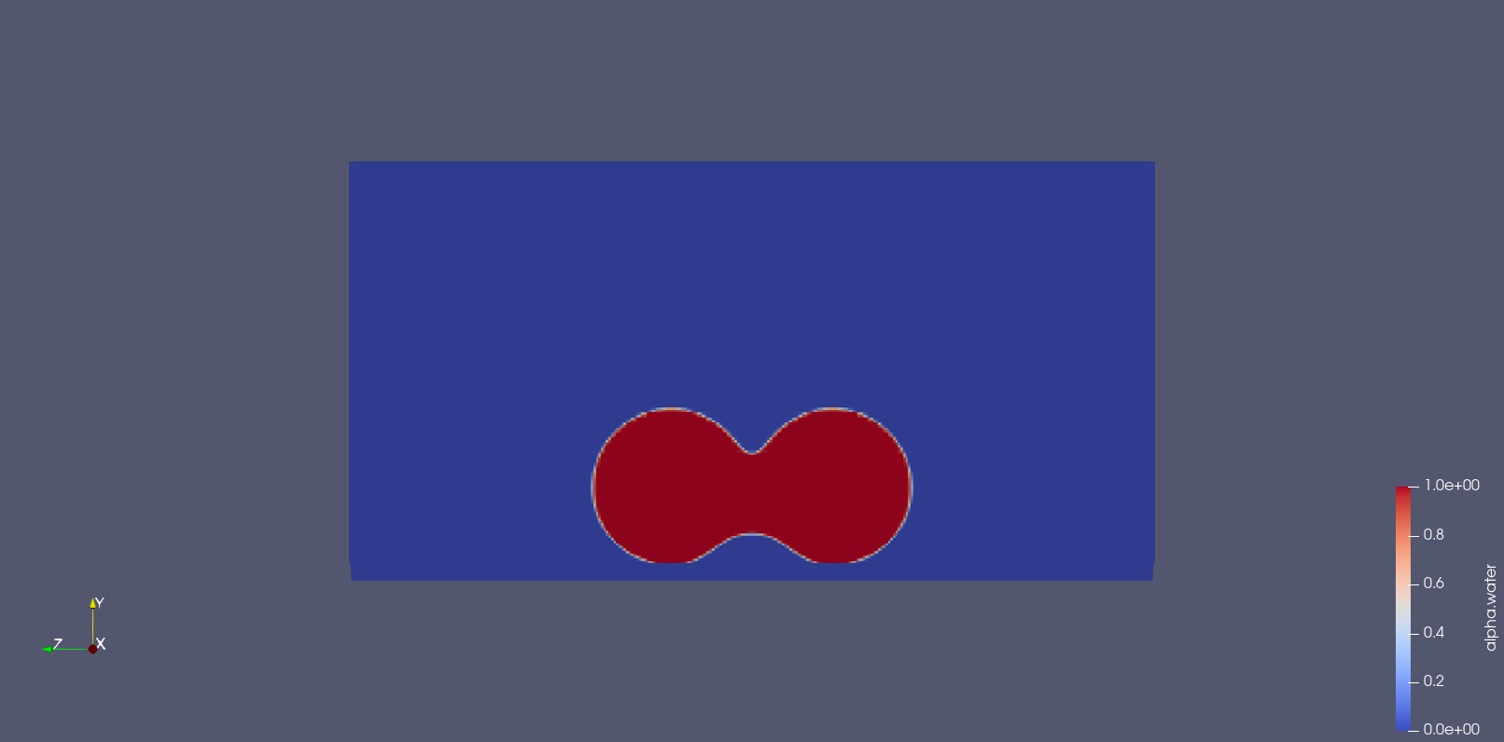

t = 0s t = 0.0002s

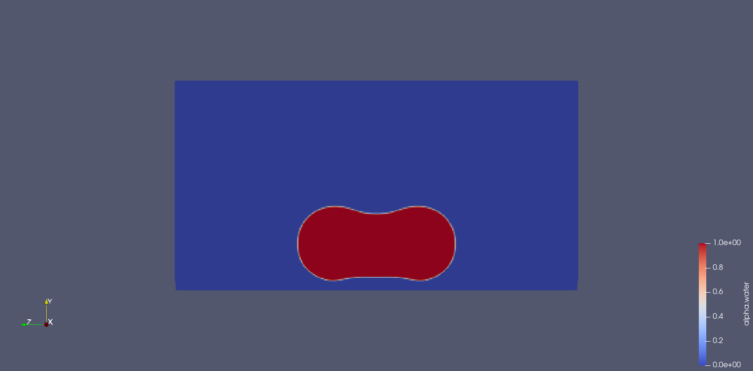 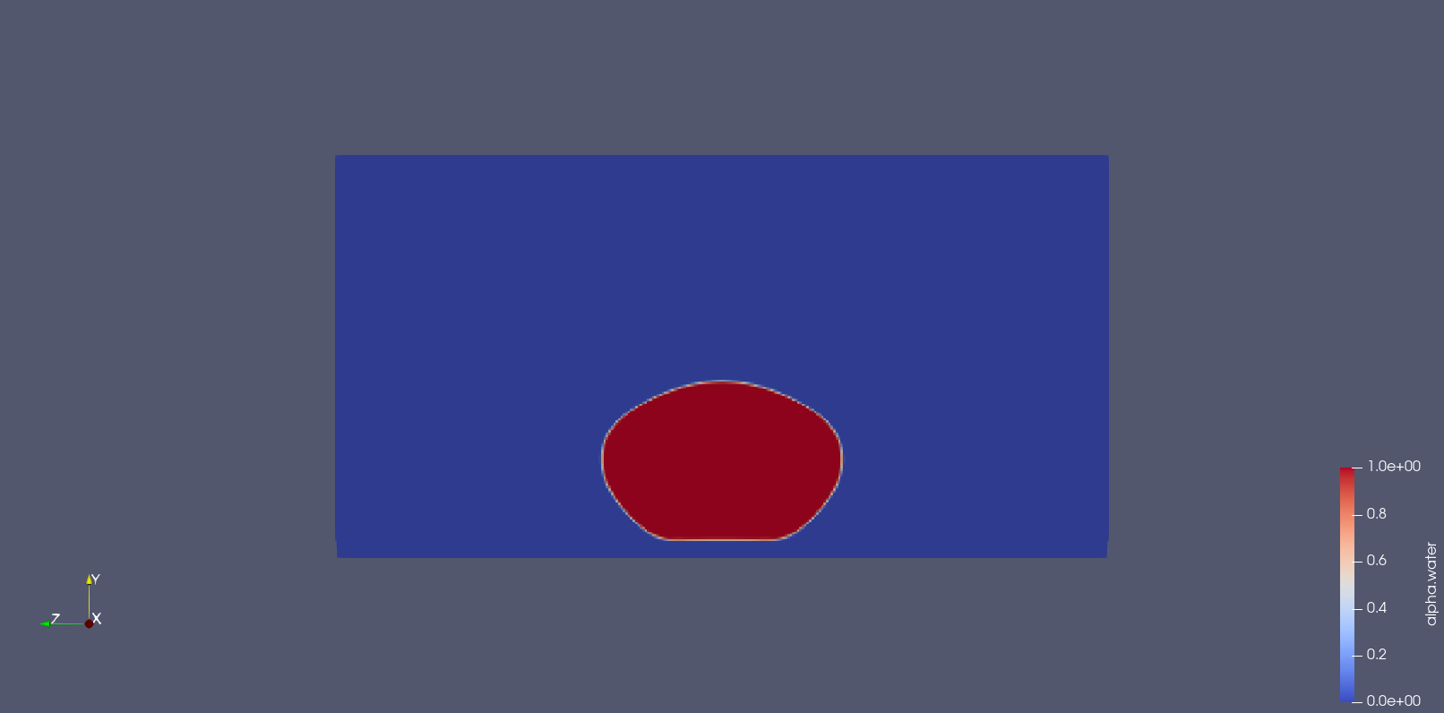

t = 0.0004s t = 0.0006s

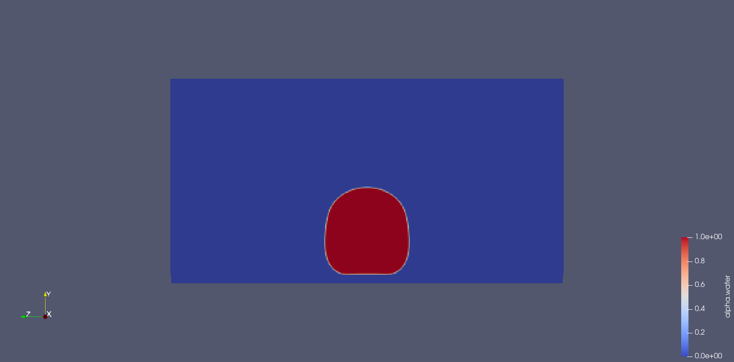 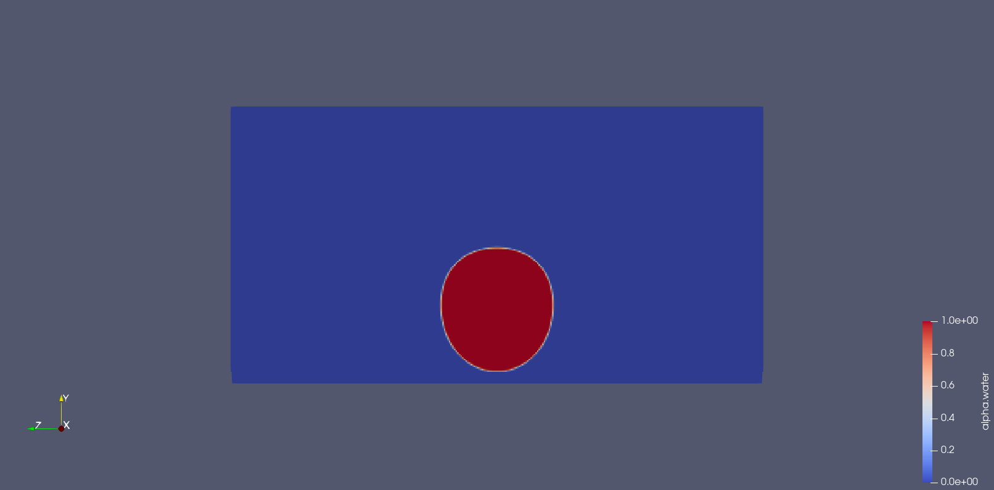

t = 0.0008s t = 0.001s

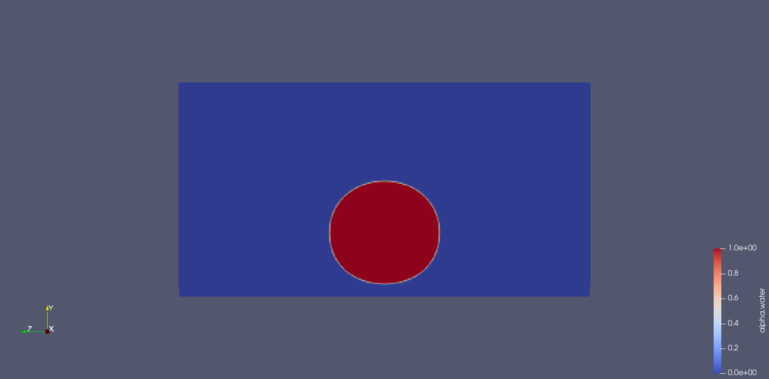 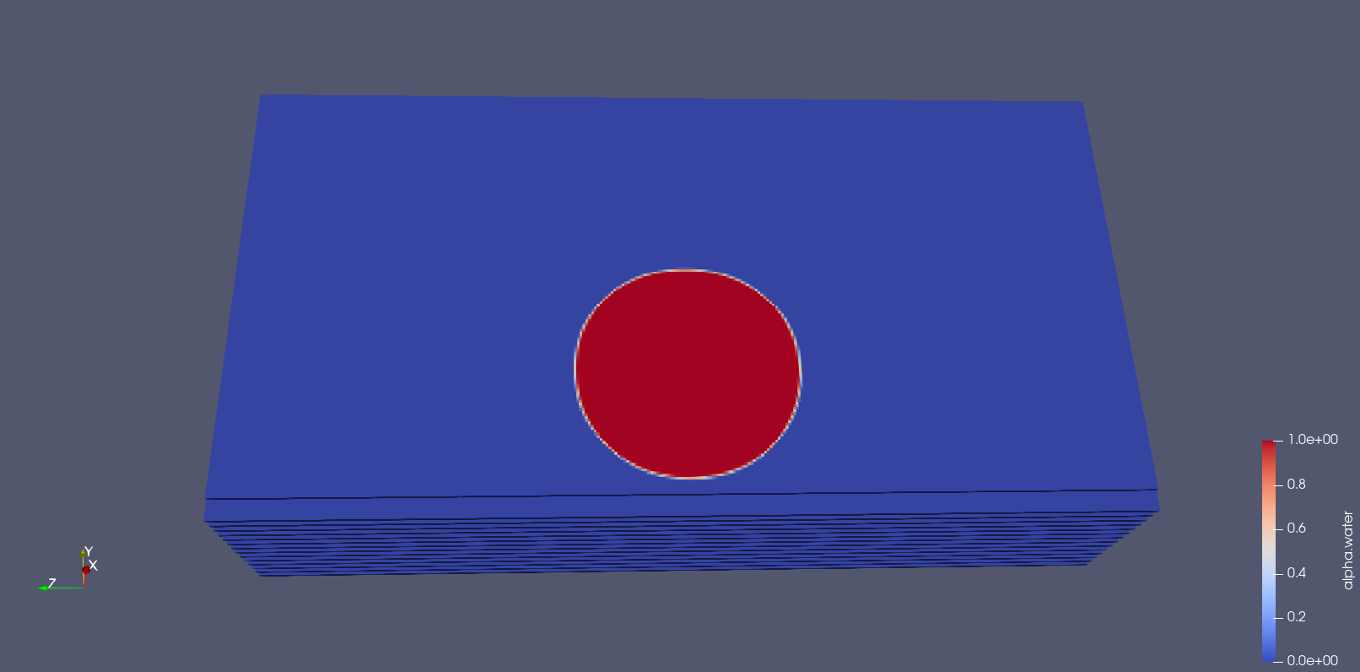

t = 0.0015s t = 0.002s

Figure vii Time evolution of the two droplets coalescing on a biphilic surface along the groove with droplet jumping after coalescing.

# **CHAPTER 5**

# **RESULTS AND DISCUSSIONS**

### ***Vacuum Test***

We conducted the first vacuum test to test the chamber, but the chamber could not attain the required pressure of 0.01 mbar, and the leakage rate was also relatively high after the vacuum pump was shut off.

Figure viii Leakage Test of the Chamber. The minimum pressure achieved was 0.13 mbar and a leakage rate of 359.28 mbar/hr.

There could be two significant sources of leakage in the setup: the ports where different components such as pressure sensors, steam inlet, outlet, etc. are connected to the chamber and the other from the front of the chamber where plexiglass is connected.

So, we tried to resolve the issues one by one by first focusing on the ports and found that the threads in the setup holes were worn, and the screws were not tightened enough. As Teflon is a soft material, this issue can occur in the future also after rethreading, so we inserted metallic inserts in the holes and used compatible screws to get a tighter fit and again conducted the vacuum test. Still, the results didn’t improve much.

Figure ix Leakage Test of the Chamber. The minimum pressure achieved was 0.13 mbar and a leakage rate of 352.44 mbar/hr.

So, we concluded that the primary source of the leakage was from the front, so we changed the O-ring in the front part and added metallic inserts in the holes whose threads had been worn, and again conducted the test and found significant improvement.

Figure x Leakage Test of the Chamber. The minimum pressure achieved was 0.05 mbar and a leakage rate of 38.16 mbar/hr.

We applied high vacuum grease on the gasket at the front plexiglass to further seal the experimental setup and significantly improved it to achieve the desired results. The leakage rate obtained was well within our 0.5 mbar/hr threshold. So, we conclude that the grease was working to our expectations.

Figure xi Leakage Test of the Chamber. The minimum pressure achieved was 0.04 mbar and a leakage rate of 0.2 mbar/hr at 20 mbar.

## ***Sensors Connectivity***

### *Pressure Sensors*

Pressure sensors are connected to NI-DAQ to acquire the signals. The pressure Sensor (TPR 270) is connected to pin number 4, while the pressure sensor (CMR 362) is connected to pin number 5.

### *PT100 Sensors*

These sensors are connected to Keithley DAQ for temperature measurements. Four PT100 sensors to measure the heat flux are linked from channel 209 to channel 212 in a four-wire configuration. Two PT100 sensors to measure the inlet and outlet temperature of the coolant at the back of the chamber are connected at channels no 227 and 228 in a two-wire configuration.

### *PT1000 Sensors*

These sensors are connected through Vacuum Feedthrough to the Keithley DAQ for temperature measurement. Two PT1000 sensors for ambient temperature measurement are connected to channels 225 & 226. Another two sensors to measure the surface temperature are connected to channels 223 & 224.

### *Thermocouples*

Two T-type thermocouples to measure the surface temperature are connected to channels 213 & 214 in Keithley DAQ.

## ***Tests and Improvements***

Various improvements were carried out after performing tests on the setup.

We noticed that the water was accumulating in the clamp at the bottom of the surface. To reduce the clamp-edge effect problem affecting the heat transfer, we decided to make a slot in the gasket, as shown in the figure, so that the condensate sliding down the surface passes through the slot and doesn’t accumulate on the clamps.

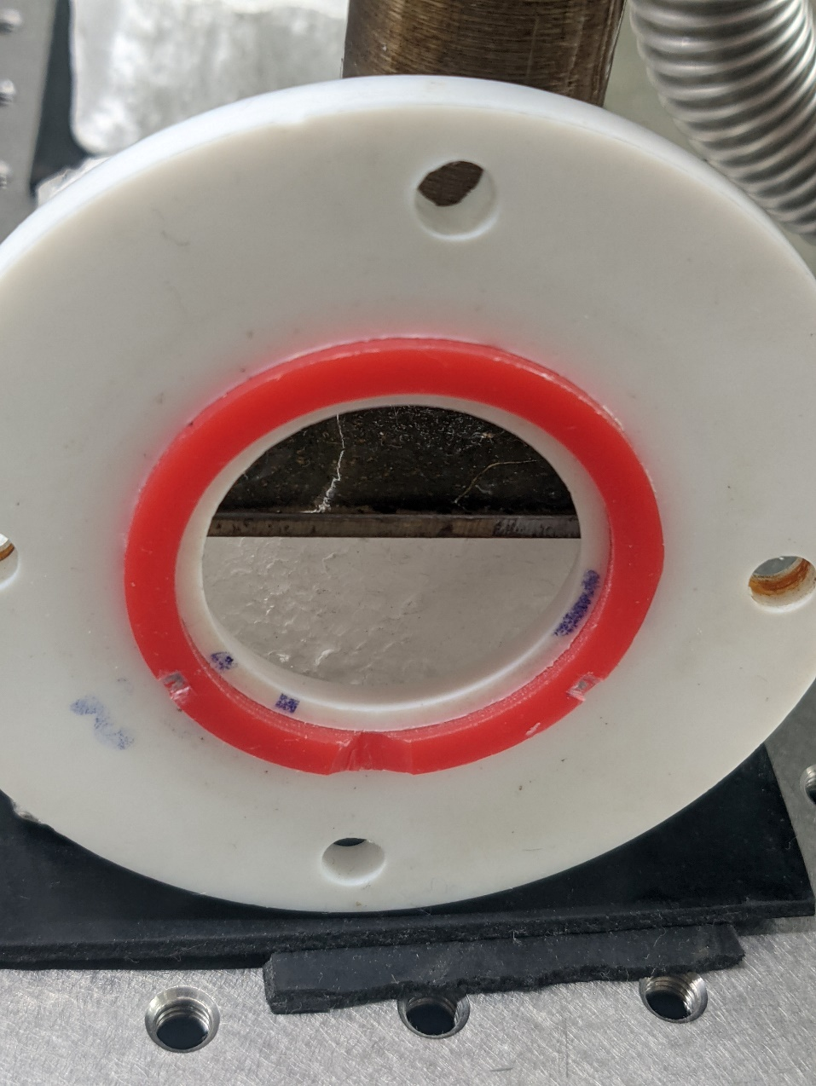

Slot on the gasket

Figure xii A slot on the gasket acting as a passage for the condensate sliding down the surface.

* We noticed that condensate was forming in the steam line as heat loss due to the length and the bents in the steam line. We tried to reduce the length of the line as much as possible and insulated the steam line to minimize the losses further.
* We have two thermocouples behind the copper surface to extrapolate the surface temperature by using the heat flux and thermal resistances for measuring the surface temperature. Still, we could not estimate the thickness of the thermal interface material; hence not able to calculate the interface thermal resistance and the surface temperature. So, we decided to put two PT1000 RTDs on the clamp’s gasket by making a slot and pasting it there. The sensors are located at 4.1 and 4.4 mm away from the axis of the copper block. The RTDs were insulated by applying varnish over the terminals so that it doesn’t get sorted in wet condition. The clamp is then pressed enough so that the sensors touch the sample surface. We assume that the lateral heat transfer is negligible and the surface temperature is uniform.

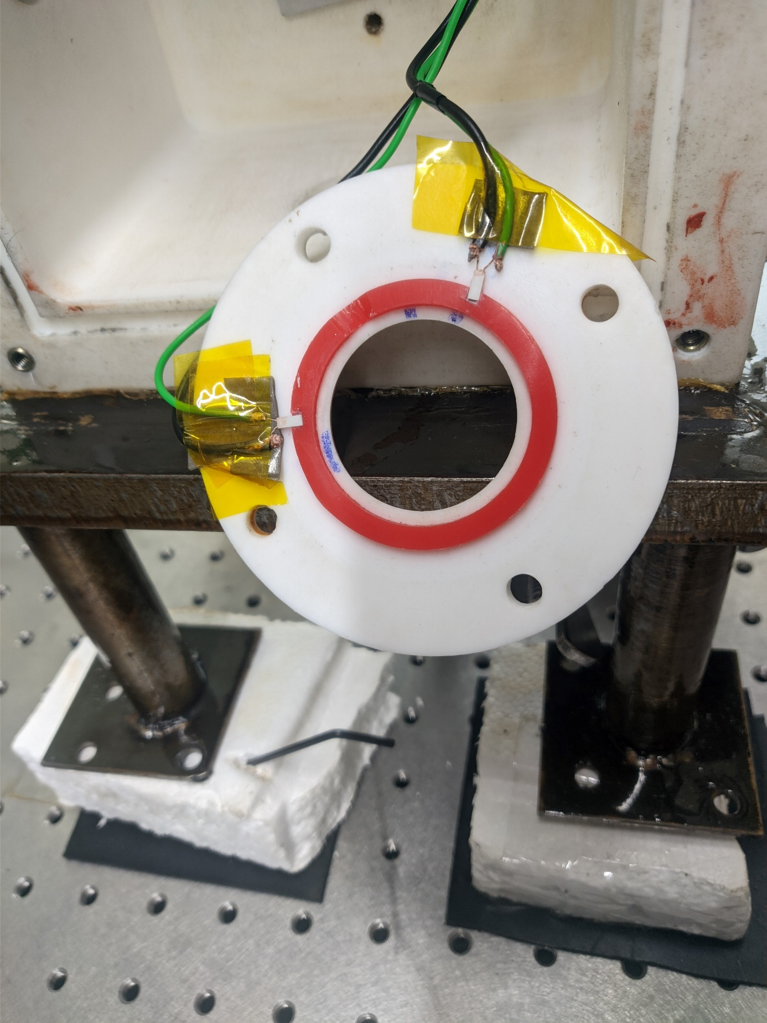

RTD sensors

Figure xiii RTD sensors are attached to the clamp to measure the surface temperature.

* We noticed that the surface sensors show ‘overflow’ sometimes after fixing the clamp over the surface. This happens due to sorting of the terminals of the sensors, try to loosen the clamp, and recheck. If this doesn’t solve the problem, open the clamp and ensure that the terminals are not sorted.
* We noticed during the initial experiments that when the steam was introduced inside the chamber with the vacuum line closed, we were not able to observe any significant heat flux in the copper block, but when the vacuum line valve was opened slightly, maintaining the pressure inside the chamber in the range 30 – 35 mbar, we were able to observe heat transfer along the copper block. The reason for the same is yet to be found.
* The saturated steam temperature at 35 mbar is 27° C while the room temperature is 24° C; a heat flux is forming inside the plexiglass resulting in condensation, which is bad because it obstructs the optical path. To solve this issue, we have ordered a film heater to heat the plexiglass so that condensate doesn’t form over the surface.

## ***Experimental Results***

* In initial experiments, we saw significantly less heat flux than the findings in the literature22 for the same Degree of subcooling in both the super hydrophilic and superhydrophobic surfaces.
* The heat flux observed for the superhydrophobic surface was less than that of super hydrophilic surface for the same Degree of subcooling. This is a surprise as superhydrophobic surfaces perform better than super hydrophilic surfaces in orders of magnitude.
* In Figure 5.7, it can be observed that around 10-12 degrees of subcooling, the readings are inconsistent as for a particular level of subcooling in the above range, there are multiple values of heat flux, and also there is a decreasing trend in the heat flux for the content mentioned above of subcooling, which is inconsistent with the findings of the literature22. This inconsistency would have happened due to the fine-tuning of the chamber pressure in the middle of the experiment. The chamber pressure fluctuates due to the degradation in the vacuuming power of the pump as water vapor forms emulsion in the pump.
* For the results shown in Figures 5.7 and 5.8, the surface temperature was calculated by extrapolating the temperature of the thermocouple placed behind copper surface using the flux obtained. For this calculation, the thermal interface material thickness was assumed to be 100µ. So, the observations mentioned above can be explained by the inaccurate assumption of the thickness of the interface material. This affects the measurement of the surface temperature, and hence the subcooling attained at the surface. So, we concluded that we were not reaching the Degree of subcooling required to achieve significant heat flux, and there was a need to measure the surface temperature accurately.

Figure xiv Heat Flux vs. Subcooling for Super hydrophilic Sample

Figure xv Heat Flux vs. Subcooling for Superhydrophobic Sample

* So, two RTD were installed at the gasket on the clamp to measure the surface temperature accurately. To reach a higher Degree of subcooling, we mixed ethylene glycol with water in equal proportion in the chiller.
* After performing the above-mentioned improvements, test was conducted for super hydrophilic sample whose results are shown in Figure 5.9. As it can be observed, for the same level of subcooling, this iteration shows higher heat flux and the Degree of subcooling that we are able to achieve is also less compared to the above-mentioned results. So, we can conclude that the calculation of surface temperature was wrong in the previous results owing to the inability in determining the interfacial thermal resistance. It can also be observed that around 4 degrees of subcooling, there are multiple heat flux readings. This happened due to the reduction in performance of the pump as explained in detail above.
* The Nusselt correlation gives the theoretical heat transfer coefficient in function of the geometry and thermodynamics variables. This theoretical value has to be compared with the measured value obtained with our setup for a super hydrophilic sample.

Figure xvi Heat Flux vs Subcooling for Super hydrophilic sample after improvements.

## ***Numerical Results***

* Numerical Simulations were performed to check the coalescence induced droplet jumping on surface with micro-channels. The simulations were performed by changing various parameters such as height, width, length of the ridge, contact angle of the surface and droplet radius.
* Among all the simulations done in 3D, none of the cases where the grooves are hydrophobic exhibited coalescence-induced droplet jumping; this may be due to energetically unfavourable conditions.
* Cases where the surface is biphilic with ridges being superhydrophobic while groves are hydrophobic exhibited coalescence-induced droplet jumping. This motivates us to investigate biphilic surface with the potential to exhibit superior heat transfer characteristics.

# **CHAPTER 6**

# **CONCLUSION**

In this project, we have assembled and tried to validate a low temperature and pressure setup for condensation experiments on various surfaces. Many iterations were done to limit the leakage in the chamber to avoid non-condensable gases in the chamber. Many tests and further improvements were carried out in the setup to measure accurate heat flux and surface temperature. A MATLAB program was made to filter the steady-state data from the raw data and also to compute the heat flux. Although few experiments were conducted but the setup is yet to be validated. Numerical Simulations were done to design a surface that can exhibit superior heat transfer characteristics.

**REFERENCES/BIBLIOGRAPHY**

(1) David Quéré, Françoise Brochard-Wyart, and P.-G. de G. *Capillarity and Wetting Phenomena: Drops, Bubbles, Pearls, Waves*; 2009; Vol. 163. https://doi.org/10.1016/j.ygcen.2009.04.018.

(2) Senthil Kumar, K.; Chen, P.-Y.; Ren, H. A Review of Printable Flexible and Stretchable Tactile Sensors. *Research* **2019**, *2019*, 1–32. https://doi.org/10.34133/2019/3018568.

(3) Zheng, Y.; Chen, C.; Pearlman, H.; Bonner, R.; Technologies, A. C. ENHANCED FILMWISE CONDENSATION WITH THIN POROUS COATING. **2016**, 1–5.

(4) Peng, B.; Ma, X.; Lan, Z.; Xu, W.; Wen, R. International Journal of Heat and Mass Transfer Analysis of Condensation Heat Transfer Enhancement with Dropwise-Filmwise Hybrid Surface : Droplet Sizes Effect. *International Journal of Heat and Mass Transfer* **2014**, *77*, 785–794. https://doi.org/10.1016/j.ijheatmasstransfer.2014.05.052.

(5) Pang, J.; Gou, J.; Huang, C.; Chen, K.; Xiao, Q.; Yao, S. Analysis of Factors Affecting Dropwise Condensation Heat Transfer Based on Theoretical Model. **2020**, *81*, 1267–1272. https://doi.org/10.3303/CET2081212.

(6) Varanasi, K. K.; Deng, T. HYDROPHOBIC-HYDROPHILIC SURFACES. **2010**.

(7) Miljkovic, N.; Enright, R.; Wang, E. N. Effect of Droplet Morphology on Growth Dynamics and Heat Transfer during Condensation on Superhydrophobic Nanostructured Surfaces. *ACS Nano* **2012**, *6* (2), 1776–1785. https://doi.org/10.1021/nn205052a.

(8) Niu, D.; Tang, G. Molecular Dynamics Simulation of Droplet Nucleation and Growth on a Rough Surface: Revealing the Microscopic Mechanism of the Flooding Mode. *RSC Advances* **2018**, *8* (43), 24517–24524. https://doi.org/10.1039/C8RA04003F.

(9) Sharma, C. S.; Stamatopoulos, C.; Suter, R.; von Rohr, P. R.; Poulikakos, D. Rationally 3D-Textured Copper Surfaces for Laplace Pressure Imbalance-Induced Enhancement in Dropwise Condensation. *ACS Applied Materials and Interfaces* **2018**, *10* (34), 29127–29135. https://doi.org/10.1021/acsami.8b09067.

(10) Sharma, C. S.; Lam, C. W. E.; Milionis, A.; Eghlidi, H.; Poulikakos, D. Self-Sustained Cascading Coalescence in Surface Condensation. *ACS Applied Materials and Interfaces* **2019**, *11* (30), 27435–27442. https://doi.org/10.1021/acsami.9b07673.

(11) Zhang, Y.; Klittich, M. R.; Gao, M.; Dhinojwala, A. Delaying Frost Formation by Controlling Surface Chemistry of Carbon Nanotube-Coated Steel Surfaces. *ACS Applied Materials and Interfaces* **2017**, *9* (7), 6512–6519. https://doi.org/10.1021/acsami.6b11531.

(12) Tang, Y.; Yang, X.; Li, Y.; Lu, Y.; Zhu, D. Robust Micro-Nanostructured Superhydrophobic Surfaces for Long-Term Dropwise Condensation. *Nano Letters* **2021**. https://doi.org/10.1021/acs.nanolett.1c01584.

(13) Hou, Y.; Yu, M.; Chen, X.; Wang, Z.; Yao, S. Recurrent Filmwise and Dropwise Condensation on a Beetle Mimetic Surface. *ACS Nano* **2015**, *9* (1), 71–81. https://doi.org/10.1021/nn505716b.

(14) Alizadeh-Birjandi, E.; Alshehri, A.; Kavehpour, H. P. Condensation on Surfaces With Biphilic Topography: Experiment and Modeling. *Front Mech Eng* **2019**, *5*, 38. https://doi.org/10.3389/FMECH.2019.00038/BIBTEX.

(15) Anderson, D. M.; Gupta, M. K.; Voevodin, A. A.; Hunter, C. N.; Putnam, S. A.; Tsukruk, V. v.; Fedorov, A. G. Using Amphiphilic Nanostructures to Enable Long-Range Ensemble Coalescence and Surface Rejuvenation in Dropwise Condensation. *ACS Nano* **2012**, *6* (4), 3262–3268. https://doi.org/10.1021/nn300183d.

(16) He, M.; Zhang, Q.; Zeng, X.; Cui, D.; Chen, J.; Li, H.; Wang, J.; Song, Y. Hierarchical Porous Surface for Efficiently Controlling Microdroplets Self-Removal. *Advanced Materials* **2013**, *25* (16), 2291–2295. https://doi.org/10.1002/adma.201204660.

(17) Winter, R. L.; McCarthy, M. Dewetting from Amphiphilic Minichannel Surfaces during Condensation. *ACS Applied Materials and Interfaces* **2020**, *12* (6), 7815–7825. https://doi.org/10.1021/acsami.9b21265.

(18) Paxson, A. Condensation Heat Transfer on Nanoengineered Surfaces. **2011**.

(19) Emmerich, C. Design of an Experimental Setup for the Observation of Condensation at Low Pressure. **2016**, No. August.

(20) Ropar, I. I. T. DEPARTMENT OF MECHANICAL ENGINEERING B-Tech Project Report On Miniature Thermal Power Plant Submitted By Ajay Yadav ( 2016meb1145@iitrpr.Ac.in ) Supervised By Dr . Chander Shekhar Sharma Table of Contents. 1–32.

(21) *InterFoam - OpenFOAMWiki*. https://openfoamwiki.net/index.php/InterFoam#Equations (accessed 2021-09-23).

(22) Donati, M.; Lam, C. W. E.; Milionis, A.; Sharma, C. S.; Tripathy, A.; Zendeli, A.; Poulikakos, D. Sprayable Thin and Robust Carbon Nanofiber Composite Coating for Extreme Jumping Dropwise Condensation Performance. *Advanced Materials Interfaces* **2021**, *8* (1), 2001176. https://doi.org/10.1002/ADMI.202001176.

# 

# **APPENDIX**

## ***Matlab Code***

### *Steady State Check*

Data = superhydrophilic204{:,:}; % read the raw data

s = size(Data); % size of the data

m = s(1); % total readings

th = 0.3; % threshold for the standard deviation

count = 0;

%% running a loop taking 120 rolling datapoints to check steady-state

for i = 1:m-120

v = Data(i:i+119,:);

dev = std(v);

bool = false;

for j = 4:11

if dev(j) > th

bool = true;

break

end

end

if bool == true

continue

else

count = count + 1;

a = mean(Data(i:i+119,:));

writematrix(a(4:11),'steady_superhydrophilic_20_4.csv','WriteMode','append')

end

end

### *Heat Flux calculation*

data = readtable( "steady_superhydrophilic_20_4.csv" ); % Read the steady-state data

Data = data{:,:};

s = size(Data); % size of the input data

m = s(1); % total steady-state readings

x = [0; 16; 24]; % relative position of the block RTD's

k = 400; % thermal conductivity of block in (W/mK)

% running a loop to calculate the heat flux

for i = 1:m

y = Data(i,[6,7,8]).';

fitobject = fit(x,y,'poly1'); % linear least-square fit

c = coeffvalues(fitobject); % slope of the fit in (K/mm)

q = -c(1)*1000*k; % Heat Flux (W)

Tinf = mean(Data(i,[2,3])); % Steam temperature (C)

HTC = q/(Tinf - Data(i,1)); % Heat Transfer Coefficient

a = [Tinf, Data(i,1),q,HTC]; % Data(i,1) is surface temperature

writematrix(a,'superhydrophilicAL_flux1_20_4.csv','WriteMode','append') % writing the data to a new file

end